**iWish**

Project Proposal

By

**Mr. Visava Chumnuam 552115067**

**Mr. Saksorn Khongsirirat 552115070**

Department of Software Engineering

College of Arts, Media and Technology

Chiang Mai University

Project Advisor

**________________________**

**Mr.Kittitouch Suteeca**

**Document History**

|  |  |  |  |  |  |  |  |
| --- | --- | --- | --- | --- | --- | --- | --- |
| **Document Name** | **Version** | | **Status** | **Date** | **Viewable** | **Reviewer** | **Responsible** |
| **Documents** | | | | | | | |
| iWish- Project Proposal_V.0.1.docx | - Add Chapter1  - Introduction & Background  - Add Chapter2  - Business Review  - Business Tools  - Software review  - Technology Review  - Development Tool Review  - Add Chapter3  - Quality Standards  - Add Chapter4  - Project Plan  -Add Chapter5  - References | | Draft | 20-05-2015 | VC, SK, KS | VC, SK | VC, SK |
| iWish- Project Proposal_V.0.2.docx | -update Abstract  -update Chapter2  - Technology Review  - Development Tool  -update Chapter4  -update Chapter5  - References | | Draft | 21-05-2015 | VC, SK, KS | VC, SK | VC, SK |
| iWish- Project Proposal_V.0.3.docx | -update Abstract  -update Chapter2  - Technology Review  - Development Tool  -update Chapter4  -update Chapter5  - References | | Draft | 23-05-2015 | VC, SK, KS | VC, SK | VC, SK |
| **Document Name** | **Version** | | **Status** | **Date** | **Viewable** | **Reviewer** | **Responsible** |
| **Documents** | | | | | | | |
| iWish- Project Proposal_V.0.4.docx | -update Chapter2  -Overview  -Scenario Summary  -Technology Review  -Development Tool  -update Chapter4  -Objective  -Deliverable and limit  -update Chapter5 | Draft | | 29-05-2015 | VC, SK, KS | VC, SK | VC, SK |
| iWish- Project Proposal_V.0.5.docx | -update Chapter4 | Release | | 06-06-2015 | VC, SK, KS | VC, SK | VC, SK |
| iWish- Project Proposal_V.1.0.docx | -update Chapter 2  -Overview  -update Chapter4  -Objective  -Deliverable and limit | Release | | 26-06-2015 | VC,SK,KS | VC, SK | VC,SK |

**\*VC = Visava Chumnuam**

**\*SK = Saksorn Khongsirirat**

**\*KS = Kittitouch Suteeca**

**Abstract**

Currently, shopping to buy some products is the thing that all people have to do. Sometimes they need to buy products. But they forget. They have to go back to the department store again. It will make them waste money and time. Sometimes, they want to know how much of the total price of the product to manage their budget. It will be better if they have an application that can help them to handle this problem.

So this project is a client-server architecture that consists of an Android application for client side and web application for the server side.

For server site, the department store has to login to the system to identify themselves. Then the system will let the department store can manage the product in the database by adding, editing and deleting the product.

For client site, this application can help customer remind and manage what products that the customer wants to buy and budgets that the customer wants to use by making a wish list. When customer scans a barcode or reads NFC (Near field communication) tag by using their smartphone to identify the product. Then this application will bring data from storage that manages by a web application. After that this application will calculate the total price of products and marked products on wish list that customer scan or read.

This project will give customers more easy, quickly and conveniently for manage their budgets. And help them to remind what they need to buy to save their time and money.

**Table of contents**

**Chapter One | Introduction and Background**……………………………….………...…....**6**

**Chapter Two | Literature Review**……………………………………....….…………..........**7**

2.1 Business Review……………………………………………………..…….……….....7

2.2 Business Tools and Software Review………………………………………………...9

2.3 Technology Review……………………………………………………………....….11

2.4 Development Tool Review……………………………………………….……...…..16

**Chapter Three | Quality Standard**…………………...…………………………….…...….**18**

3.1 ISO29110 for Very Small Entity (VSE).....................................................................18

3.1.1 Project Management process……………………………....……………...….18

3.1.2 Software Implementation process………………………....…………...……..19

**Chapter Four | Project Plan**………………………………………………....……...……....**20**

4.1 Motivation………………………………………………………….…...…..…...…..20

4.2 Aims and Objectives…………………………………………………….........……..20

4.3 Deliverables and Limits…………………………………………………….....…….21

4.3.1 Deliverables………………………………………………………….….…….21

4.3.2 Limits………………………………………………………………..………..22

4.4 Schedule & Milestones…………………………………………………...…...……..22

**Chapter Five | References**………………………………………………………….....…….**28**

# **Chapter One | Introduction and Background**

Currently, shopping to buy some products is the thing that all people have to do. Sometimes they want to buy a lot of products. But when they bought the products and took the products to their home. They find they forgot to buy some product. It is a big problem if the distance from their home to the supermarket is far. If those products are needed, they have to go to the supermarket again to buy it. They will waste the time and money to get back to the supermarket. Or sometimes, they want to know how much of the total price of the products to manage their budget. It will better if they have some tool that they can manage their shopping.

And now, Android phone is a one of the popular smartphone.  [ 18 ] It has up to 80% of market shares of the smartphones in the world. That means there are about up to 800 million people use the Android phone.

So we will create an Android application for the customers to solve those problems by using NFC (Near field communication) and Barcode technologies. The application will let the customers manage their shopping appropriately. Also the server site, we will create a web page for admin to manage products in the database.

**Chapter Two | Literature Review**

**2.1 Business Review**

**2.1.1 Overview**

Currently, shopping to buy some products is the thing that all people have to do. Someone bought from mini-mark. Someone bought from a supermarket. The problem will happen when bought some product from a supermarket. The supermarket has many product type and product brand more than mini-mark. The customer may forget to buy some product. And when paying money for the product, they found the total price is over than their budget. So, we will create an Android application to handle that problem that we call iWish.

iWish is an Android OS (Operating System) application that can help the customers to manage shopping. Our project is separate into two parts. The first is a supermarket site. The admin will provide NFC tag and barcode that linked to a database that managed by the admin. When the customers wants to buy a lot of products. The customer may forget to buy something. But if the customers use this application, they will not forget to buy the products. Because the customers can set wish list what are the products that want to buy. And can set the expected price. The wish list feature can sort the product in the list by nearest distance. When they go to shopping, the customers can use this application to get the information such as name, net weight and price of each product. By using NFC or barcode scanner features. The application will connect to the database and bring the information of products to the customers. Then the customers can use the application to compare or calculate the total price of the product.

**2.1.2 Target**

The main target of iWish application is providing convenience to customers to make no forget to buy products. The customers can go shopping and compare prices each product brand in the same category.

**2.1.3 Benefit**

* Customers get more facility for shopping
* The supermarket can improve their service to the customer

**2.1.4 Scenario Summary**

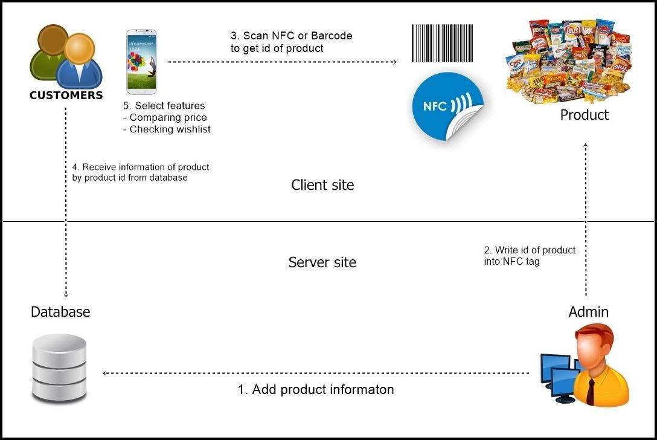

**Figure 1: Scenario Summary**

**2.2 Business Tool/Software Review**

**2.2.1 Barcode Price (BCPrice)**

BCPrice is an Android OS application that helps the user to calculate the total price that the user use in each day. The user can get total price by scan barcode and then input amount of product that user scan, then the application will calculate the total price for the user.

**Pros**

* The application is free for download.
* Same product different price.
* Easy to use.

**Cons**

* Product price must be set by user at first time barcode scan.
* Product’s information only have barcode’s number and price.

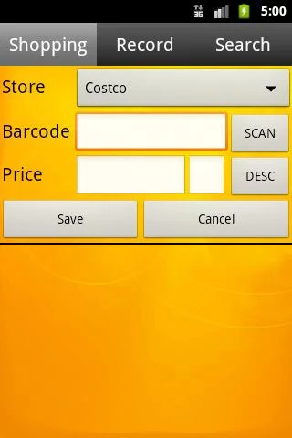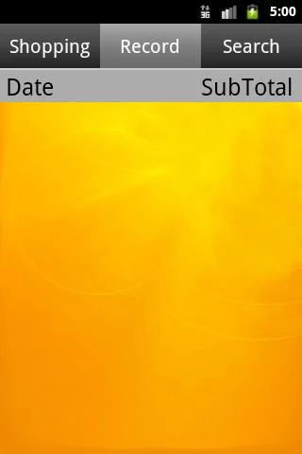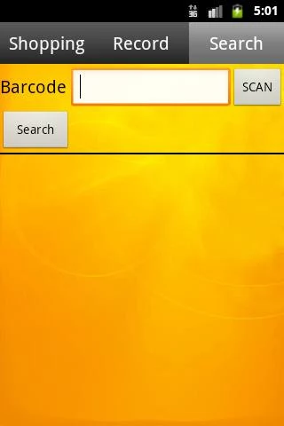

**Figure 2: Barcode Price User Interface**

**2.2.2 DoRAKAR**

DoRAKAR is an iOS application that compares product’s price of all supermarkets in Thailand. The user can compare price by scan barcode and then the application will give product’s details for the user and each supermarket’s prices according to the product that user scan.

**Pros**

* The application is free for download.
* Compare price with all supermarket.
* Easy to use.

**Cons**

* Not compare with similar product.
* Some products’ price not up to date.
* Only online shopping’s price.

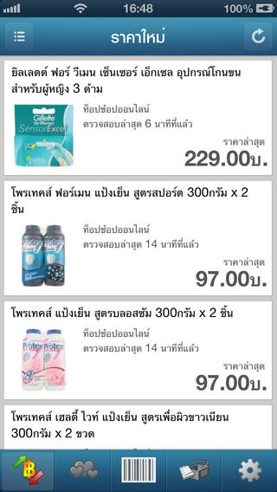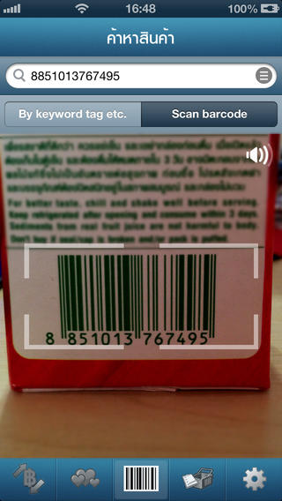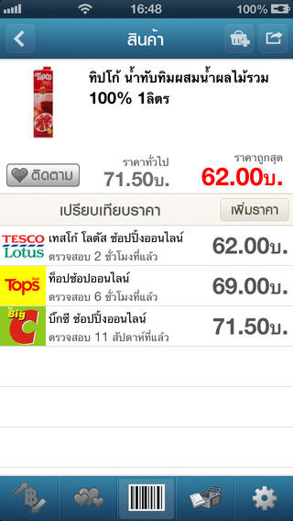

**Figure 3: DoRAKAR User Interface**

**2.3 Technology Review**

***2.3.1 Android Operating System***

Android operating system is based on Linux community and build for a Multi-Screen. Android can run on many handheld devices around the world, and now it supports new thing, new form factors such as wear, TV and auto. But to develop an Android application. The developer must handle the one problem that is the fragmentation of Android phones.

***Alternative Technology***

* iOS

iOS is a one popular operating system of the mobile phone. The distinctive point from another operating system is stability. Because it is not an open source software. It makes the iOS has high security and stable application.

***The selection of this technology***

We select the Android OS because the Android operating system support many devices. And from idc.com which is analyze product and service in the world. They show a graph of the smartphone market share, the Android operating system is the high number of the users. We focus on large number users that can use our application. So we select to develop the Android application.

***2.3.2 Java***

Java is a programming language which for simulate every networked application. And it is standard for developing delivering mobile applications, games, web-based content, and enterprise software. The advantage of Java language is the developer can write software on one platform. And can run the software on almost other platforms.

***Alternative Technology***

* C# language

***The selection of this technology***

Java is a global standard for developing and delivering embedded and mobile applications. And we want to develop the Android application which using the Java programming language. So we select this technology for development the Android application.

***2.3.3 XML***

XML stands for Extensible Markup Language. It uses to describe data that carrying information for software and hardware and use for represent data. And supports by Android Studio for creating a user interface.

***The selection of this technology***

For developing android application’s user interface, we use XML because it easy to coding. Also, create a user interface to optimize according to screen size.

***2.3.4 Json***

JSON stands for JavaScript Object Notation. It is a data-interchange format. It is easy for humans to read and write. It is easy for machines to parse and generate. It is based on a subset of the [JavaScript Programming Language](http://javascript.crockford.com/). JSON is a text format that is independent but uses conventions that are familiar to C, C++, C#, Java, JavaScript, Perl, Python, and many others.

***The selection of this technology***

We use Json to make our android application interact with our web application for interact with database.

***2.3.5 HTML***

HTML stands for Hyper Text Markup Language. It is a markup language for describing the web page. Including display data or something on a web browser.

***The selection of this technology***

We select this technology because this project is not only Android application. It also has the web application for admin to manage the database. So we have to use HTML to implement the page of web application.

***2.3.6 CSS***

CSS stands for Cascading Style Sheets. It defines how HTML elements are to display on the web page including look and layout.

***The selection of this technology***

Because we need to design web application for admin, that mean we need to decorate for better looking by using CSS.

***2.3.7 JavaScript***

JavaScript is the HTML and web page programming language. It has responsibility for computing part on the web page.

***The selection of this technology***

Our web application needs to compute something and interact with a server. So, we need to use JavaScript for take responsibility on that part.

***2.3.8 Spring Framework***

Spring framework is a framework and inversion of control for Java. It provides a comprehensive programming and configuration model for Java. It makes a program to deployment on any platform without to specified deployment environment.

***Alternative Technology***

***● Laravel***

***● .NET framework***

***The selection of this technology***

Our web application is using Java language. And it must be accessed by any platform. So, why we need to use this technology to develop an web application. Also, it support MVC.

***2.3.9 angularJS***

angularJS is HTML enhanced for a web application. It makes a web page become to a dynamics view. And also make a web page has some result to an environment. Such as extraordinarily impressive, readable, and quick to develop.

***The selection of this technology***

We use MVC that mean our views need to be a dynamic web page. It can change following the result of environment. So, that is the reason we use angularJS.

***2.3.10 Bootstrap***

Bootstrap is a collection of tools to use for creating websites and web applications. It makes web page can optimize itself to support many shape or size of devices.

***The selection of this technology***

We choose the Bootstrap because our web application needs to optimize to any shape of the device. To prevent the mistake layout from many fragmentations of the device.

***2.3.11 node.JS***

Node.js is a runtime Javascript that built on Chrome browser. It uses for data-intensive real-time applications that run across devices.

***The selection of this technology***

This tool will help our web application faster than not use because it make our web application to become real-time application.

***2.3.12 Barcode***

Barcode is a readable represent of data that relate to object that it attached. Data represented by the width and the space of line. Barcode can be scan by camera with software or scanner.

***The selection of this technology***

We can said “All of the product that sell in a supermarket has a barcode”. And we create an Android application about manage shopping in the supermarket So, our application must support this technology.

***2.3.13 NFC***

NFC stand for Near Field Communication. It is a relatively new technology that built-in almost new smartphone. It let the smartphone communication or exchange data to another device by using radio frequency. To communicating to another device, one device act as the transmitter to send data. And another device act as receiver to read the data. The receiver needs some power to interpret the data. But transmitter no needs the power such as NFC Tag.

***The selection of this technology***

We choose the NFC for make multi-ways for the customer to use our application.

**2.4 Development Tool Review**

***2.4.1 Android studio***

Android Studio is a tool to develop an Android application based on [IntelliJ IDE](https://www.jetbrains.com/idea/)A. It is officially for IDE.

***Alternative Tool***

* Xamarin

***The selection of this tool***

We need tool for developing Android application. This tool is official and has many helping tool that will help us to develop it easier.

***2.4.2 IntelliJ IDEA***

IntelliJ IDEA has support by frameworks and coding assistance for JavaScript, HTML and CSS including AngularJs and Node.js

***Alternative Tool***

***●***  notepad

***The selection of this tool*** With this tool, we will developing web application easier according to the built-in function of this tool. That is a reason to select IntelliJ IDEA.

***2.4.3 Apache TomCat***

Apache Tomcat is an open source software implementation of the Java Servlet and JavaServer Pages technologies.

***The selection of this tool*** we need Java server for deploy our web application.

***2.4.4 MySQL***

MySQL is a popular open source database. Many of large website including Facebook, Google and Adobe use MySQL to save their time and money carry out their website, business system and packaged software.

***The selection of this tool***

We need database to store our product’s information and authorized user’s information.

# **Chapter Three | Quality Standard**

## 3.1 ISO29110 for Very Small Entity (VSE)

ISO29110 is a guide applies to a Very Small Entity (VSE), enterprise, organization, department or project up to 25 people, dedicated to software development. The Guide provides Project Management and Software Implementation processes which integrate practices based on the selection of ISO/IEC 12207- Systems and Software Engineering —Software Life Cycle Processes and ISO/IEC 15289 Software Engineering – Software Life Cycle Process – guidelines for the content of software life cycle process information products (documentation) standards elements.

### 3.1.1 Project Management process

The purpose of the Project Management process is to establish and carry out in a systematic way the tasks of the software implementation project, which allows complying with the project’s objectives in the expected quality, time and cost.

Activities

- Project Planning Process

- Project Plan Execution Process

- Project Assessment and Control Process

- Project Close Process

### 

### 3.1.2 Software Implementation process

The purpose of the Software Implementation process is the systematic performance of the analysis, design, construction, integration and tests activities for new or modified software products according to the specified requirements.

Activities

- Software Implementation Initiation Process

- Software Requirements Analysis Process

- Software Architectural Design Process

- Software Construction Process

- Software Integration and Test Process

- Software Delivery Process

**Chapter Four | Project Plan**

**4.1 Motivation**

This project will improve the customer’s life to shopping in the supermarket. Sometimes they want to buy some products. But when they bought the goods and took it to their home. They find they forgot to buy some products. It is a significant problem. If the distance from their home to the supermarket is far. And if those products are needed, they have to go to the supermarket again to buy it. They will lose the time and money to get back to the shop. It will be better if they have some application that they can use it to manage the product that they want to buy. And Android OS has the high market share on a mobile platform. And the almost android phone has NFC chip built-in.

So, we want to create an Android application for solving this problem. By using NFC and barcode technology.

**4.2 Aims and Objectives**

**4.2.1 Aims**

The aim of this project is to develop an Android application on Android phones that help the customer to manage buying the products from the supermarket.

**4.2.2 Objectives**

* To help the customers do not forget buying products that they want from the supermarket.
* To help the customers to manage budget for buying products that they want from the supermarket.
* To help the customers save times when they go to buy products from a supermarket.

**4.3 Deliverable and Limits**

**Progress I**

Web application

* Authentication System
* Product Management System

Android application

* Barcode Scanner Feature
* Shopping cart Management System

**Progress II**

Android application

* Evaluate Shopping cart System
* Wish list Feature

**Progress III**

Android application

* NFC Scanner Feature
* Product Comparing Feature

**Final Progress**

Android application

* Sorting Wish list Feature

In the final progress, we update all documents follow implemented features, and improve performance the application.

**4.3.2 Limits**

* The project iWish can support single supermarket.
* The application requires the Android phone that run by Android OS version 2.3 or later.
* The application requires the Android phone that has an NFC reader/writer built-in to use scan NFC feature.
* The application requires the Android phone that has a camera built-in to use scan barcode feature.
* The application requires an internet connection for retrieving information of a product from the database when the user uses barcode and NFC feature.

**4.4 Schedule & Milestones**

From the milestones, it will show tasks and period of time that needed to complete this project and description of each schedule and milestones.

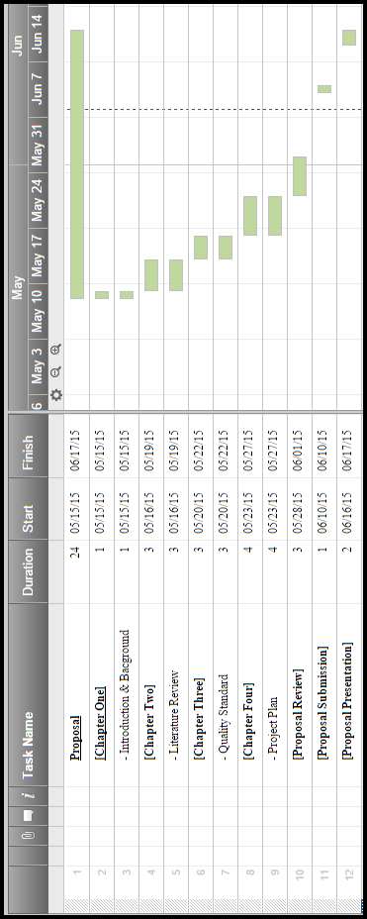

**Figure 4: Proposal Progress**

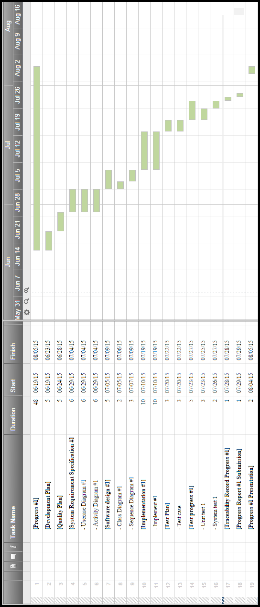

**Figure 5: Progress I**

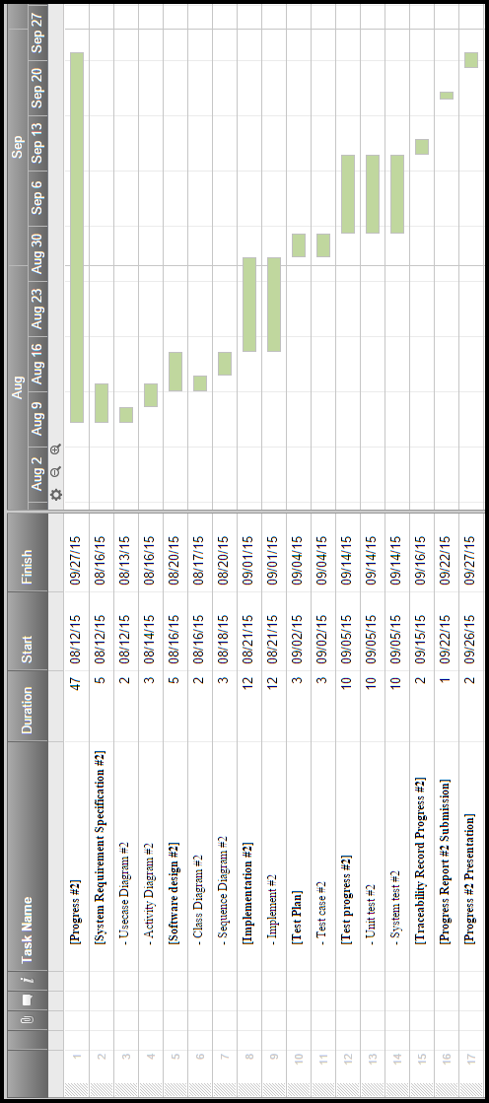

**Figure 6: Progress II**

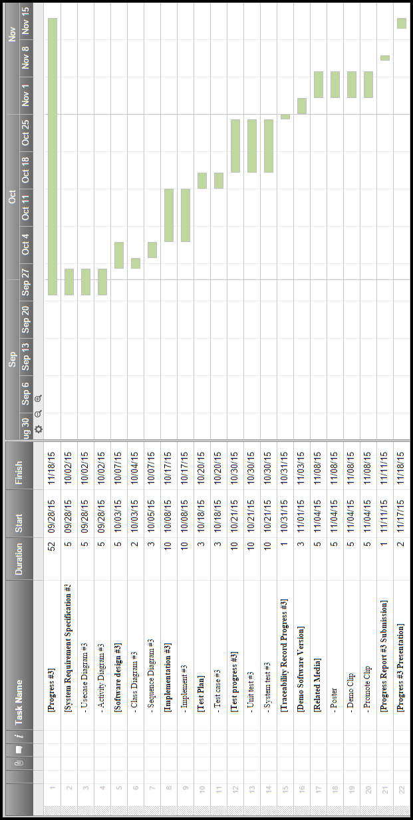

**Figure 7: Progress III**

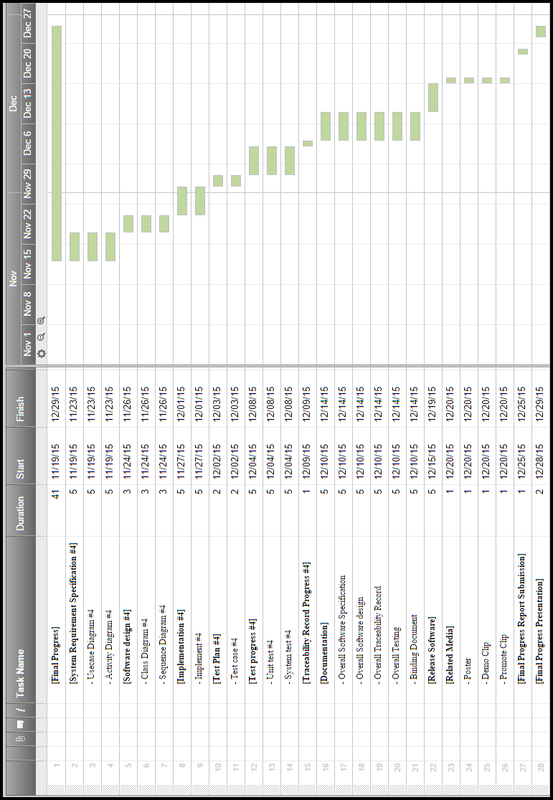

**Figure 8: Final Progress**

**Chapter Five | References**

[ 1 ] Topic: Android Operating system. Retrieved May 20, 2015, from <http://developer.android.com/about/index.html>

[ 2 ] Topic: Java. Retrieved May 20, 2015, from <https://www.java.com/en/about/>

[ 3 ] Topic: XML. Retrieved May 20, 2015, from http://www.w3schools.com/xml/xml_whatis.asp

[ 4 ] Topic: Json. Retrieved May 20, 2015, from http://json.org/

[ 5 ] Topic: HTML. Retrieved May 20, 2015, from http://www.w3schools.com/html/html_intro.asp

[ 6] Topic: CSS. Retrieved May 20, 2015, from http://www.w3schools.com/css/css_intro.asp

[ 7 ] Topic: JavaScript. Retrieved May 20, 2015, from http://www.w3schools.com/js/js_intro.asp

[ 8 ] Topic: Spring Framework. Retrieved May 20, 2015, from <http://projects.spring.io/spring-framework/>

[ 9 ] Topic: AngularJS. Retrieved May 20, 2015, from <https://angularjs.org/>

[ 10] Topic: bootstrap. Retrieved May 20, 2015, from <http://getbootstrap.com/>

[ 11 ] Topic: node.JS. Retrieved May 20, 2015, from <https://nodejs.org/>

[ 12 ] Topic: Barcode. Retrieved May 20, 2015, from http://en.wikipedia.org/wiki/Barcode

[ 13 ] Topic: NFC. Retrieved May 20, 2015, from http://en.wikipedia.org/wiki/Near_field_communication

[ 14] Topic: Android studio . Retrieved May 20, 2015, from https://developer.android.com/tools/studio/index.html

[ 15] Topic: IntelliJ IDEA. Retrieved May 20, 2015, from <https://www.jetbrains.com/idea/>

[ 16 ] Topic: Tomcat Apache. Retrieved May 20, 2015, from http://tomcat.apache.org/

[ 17 ] Topic: MySQL. Retrieved May 20, 2015, from <https://www.mysql.com/>

[ 18 ] Topic: Smartphone market share. Retrieved May 29, 2015, from http://www.digitaltrends.com/mobile/worldwide-domination-android-and-ios-claim-96-of-the-smartphone-os-market-in-2014/